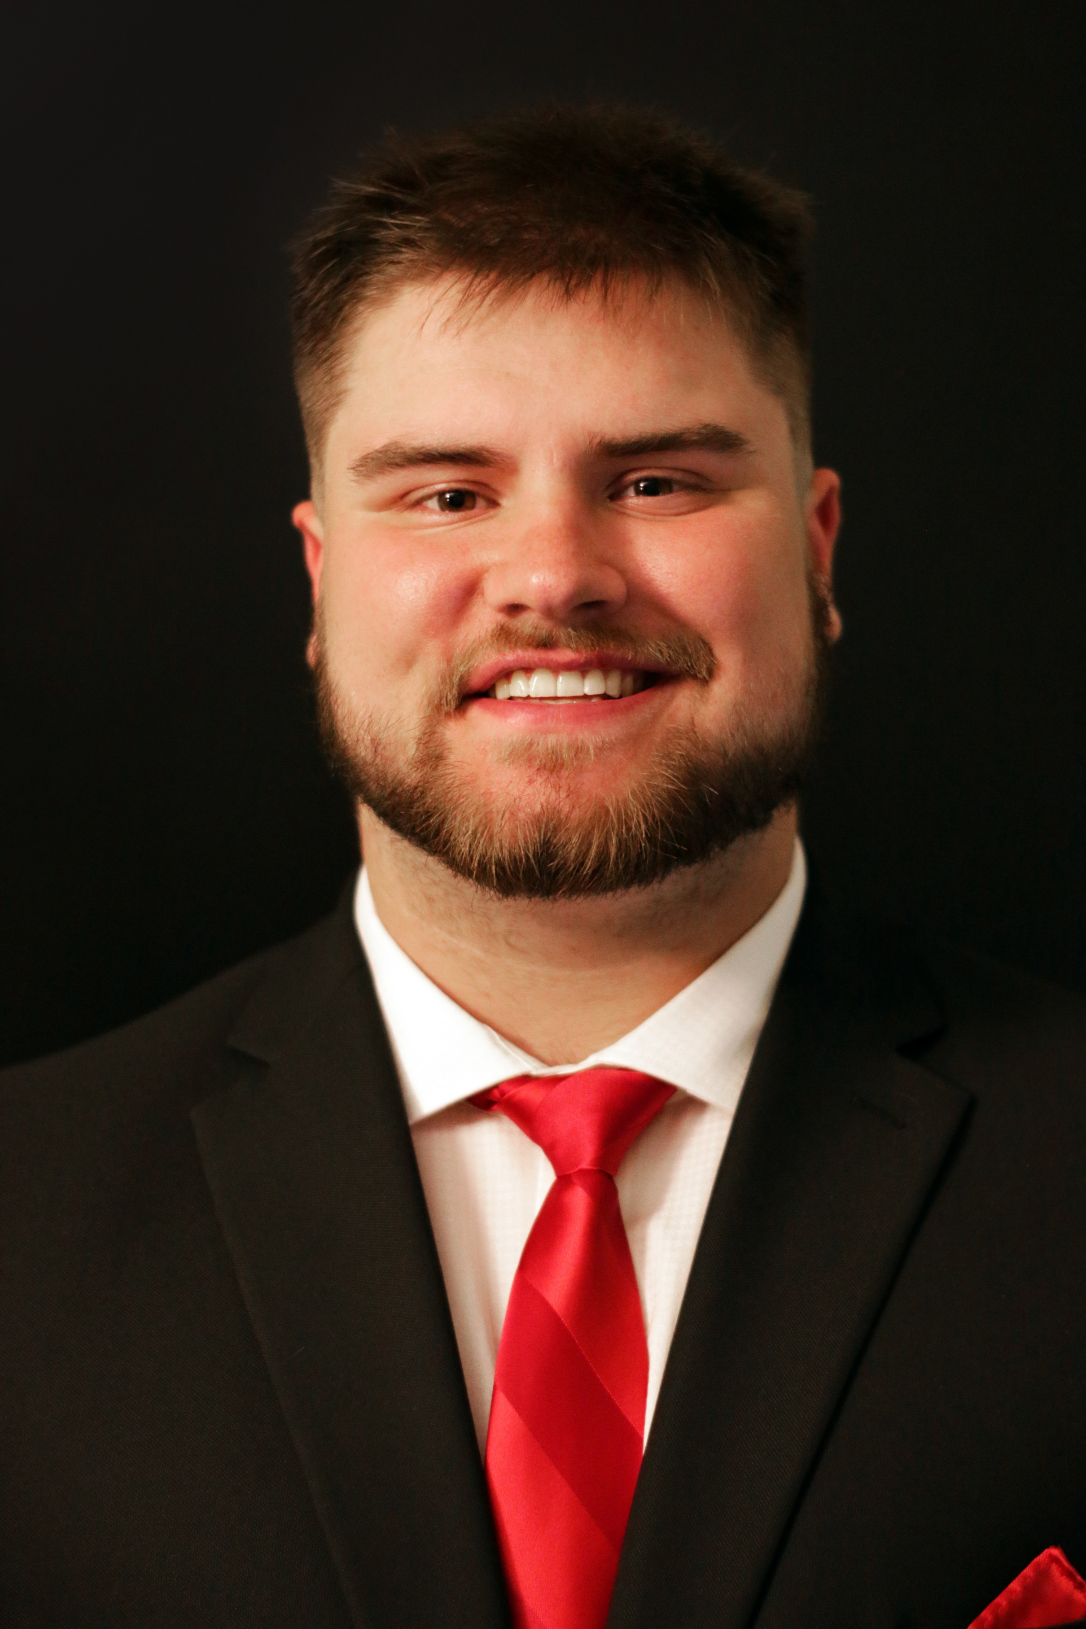 |  | Joel Zellem
Profile  Currently a Senior at Waynesburg University. I am a Communication major with a focus on sports announcing and information.  Contact  PHONE:  724-496-1025  EMAIL:  zellem65@icloud.com  Linkedin:  Joel Zellem  WEBSITE:  https://zellem65.wixsite.com/website  Hobbies  Sports  Podcasts  Weight Lifting  Video Games  Rec. Activities  REFERENCES  Doug Wilson (Professor)- 724-998-7832  Dr. Cornelius Coleman (Coach) 202-391-5130  Kyle Dawson (Boss)- 412-605-4042  Sean Seaman (Boss)- 412-848-2402 |  | EDUCATION  Riverside Beaver County High School  2014-2018  Waynesburg University- Communication  2018-2022  WORK EXPERIENCE  Altsman Seal Coating-Crew  Summer 2019 (seasonal)  Cleaning off driveways and parking lots then carrying buckets of seal coating to the crew leaders to seal coat black top. Also assisted on tennis courts and tracks  Plugh’s Country Market- Cash Register/Cook  Winter 2020  Ran register. Able to make change while engaging in conversation. Was responsible and clean enough to run register and make food at the same time. Stocked shelves every morning.  Dollar General- Sales Associate  Summer of 2019  Ran register and stocked shelves. Swept and mopped floors.  Washington Wild Things- Intern  Summer of 2022  Ran scoreboard, wrote game recaps, ran camera op, photography, videography teams social media page.  Skills  Advanced People Skills/Emotional Intelligence  Physical Strength  Works well with others  Critical thinking/problem solving  Excels in manual labor  Well Spoken  Adequate with certain tools  Adequate writing  Hubspot Academy Social Media Marking Certification Feb 24 2022

